#include<stdio.h>

#include<string.h>

#include<stdlib.h>

void push(char);

char pop();

int prece(char);

void to_post(char []);

int top=-1;

char in_fix[20];

char stack[20];

void main(){

puts("Enter the infix expression:\n");

gets(in_fix);

puts("Postfix expression:\n");

to_post(in_fix);

getchar();

}

void push(char item){

if(top>=19){

printf("Stack overflow");

}

else{

top++;

stack[top]=item;

}

}

char pop(){

char p;

if(top==-1)

printf("Stack underflow");

else{

p=stack[top];

top--;

}

return p;

}

int prece(char ch)

{ if(ch=='^')

return 3;

else if (ch=='*'||ch=='/')

return 2;

else if (ch=='+'||ch=='-')

return 1;

else

return 0;

}

void to_post(char in_fix[]){

char s,t;

char post[20];

static int index=0,pos=0;

int len;

push('(');

len=strlen(in_fix);

in_fix[len]=')';

in_fix[len+1]='\0';

while(index<=len){

s=in_fix[index];

switch(s)

{

case '(':

push(s);

break;

case ')':

t=pop();

while(t!='('){

post[pos++]=t;

t=pop();

}

break;

case '+':

case '-':

case '*':

case '/':

case '^':

while(prece(s)<=prece(stack[top])){

t=pop();

post[pos]=t;

pos++;

}

push(s);

break;

default:

post[pos]=s;

pos++;

break;

}

index++;

}

while(top>=0){

t=pop();

post[pos]=t;

pos++;

}

post[pos]='\0';

puts(post);

}

Output

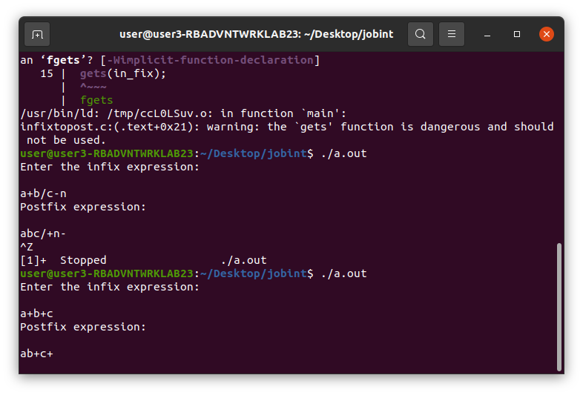

Link to Quiz

https://quiz.mygov.in/quiz/ncsa-2022/